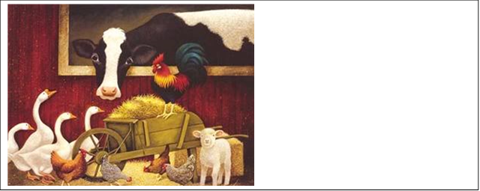 March 02, 2015 Parents of third and second graders and students,
This month will be the month of our 2/3 concert at Groves High School!! I can’t believe it is almost here already! The concert is scheduled for 7 p.m., however I am asking that you be there no later than 6:45 p.m. so that students can get situated and prepared to go on stage. There will be a rehearsal for our performance at Groves High School during the school day on March 31st. Permission slips will be sent home in the next couple of weeks. Below is what they need to wear to the concert. Every student has been assigned a part. If you have any questions, please don’t hesitate to contact me at: mheber@birmingham.k12.mi.us. Also, please make sure you check the music website, http://binghammusic.weebly.com/. There are lyrics that the students can practice with and additional information! I truly appreciate your cooperation!
Sincerely,

Maureen Heber
Vocal Music Teacher
Bingham Farms Elementary

Parts assigned:
What should I wear??

Pig: Pink t-shirt and black pants, black jeans, or black yoga pants.
Sheep: White t-shirt and black pants, black jeans, or black yoga pants.
Chick: Yellow t-shirt and black pants, black jeans or black yoga pants.
Farmers: Blue jeans and flannel top.
Bo-Peep: Dress.

